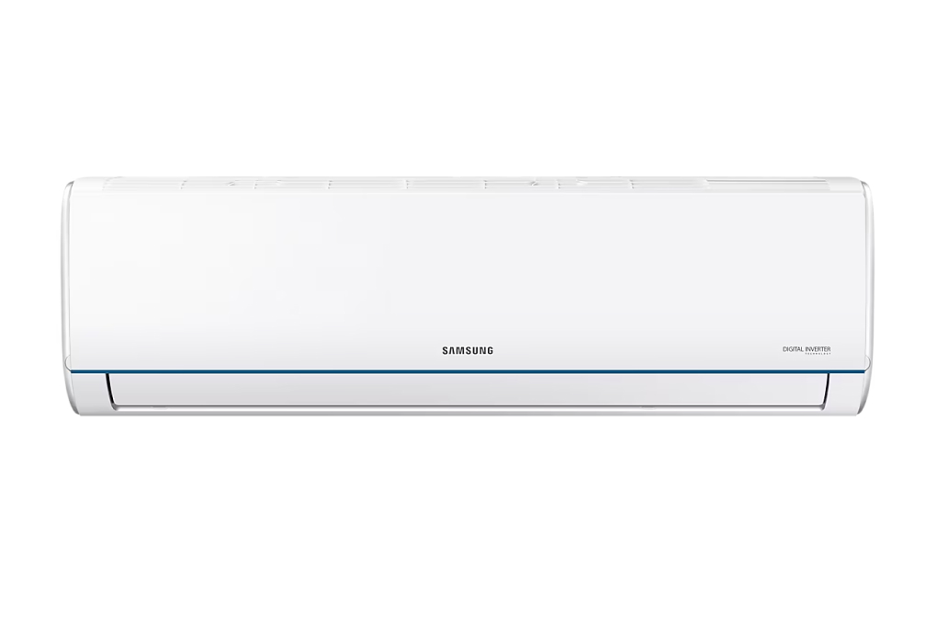

**9,390,000 VND**

(-9%)No copper pipes and supplies will be given away.Delivery only, no installation.

**Technical specifications Samsung Inverter air conditioner 1.5 HP AR12TYHQASINSV**

* Machine Type:

1 way (cooling only) With Inverter

* Cooling capacity:

1.5 HP - 12,000 BTU

* Effective cooling range:

From 15 - 20m² (from 40 to 60 m³)

* Dust filter, antibacterial, deodorant:

HD filter helps purify the air

* Power saving technology:

Digital Inverter Boost

* Rapid cooling:

Fast Cool & Comfort Cool

* Utilities:

Good Sleep mode. Timer to turn the machine on and off. Screen displays the temperature on the indoor unit. Automatically restarts when there is power

* Power consumption:

1.15 kW/h 5 stars (Energy efficiency 4.50 )

* Cooler:

Length 80.5 cm - Height 28.5 cm - Thickness 19.4 cm - Weight 8.8 kg

* Outdoor:

Length 72 cm - Height 49.5 cm - Thickness 27 cm - Weight 21.3 kg

Introducing the company 

- A brand from Korea, founded in 1938.  
- Samsung is a multi-industry corporation, with a high level of brand recognition on a global scale.  
- Samsung's products range from mobile devices, home appliances, electronics,...  
- With the strength of being the brand of a global corporation, the quality of products always reaches the highest level of perfection. , good warranty should be trusted by customers around the world.

***An air conditioner product of the Samsung brand is equipped with a variety of features to optimize cooling capabilities such as fast cooling Fast Cool & Comfort Cool, energy saving Digital Inverter Boost, HD filter to help clean air. gas.***

**Design overview**

**Cooler**

- [Samsung Inverter 1.5 HP AR12TYHQASINSV air conditioner](https://www.dienmayxanh.com/may-lanh/samsung-inverter-1-hp-ar12tyhqasinsv) is a wall-mounted air conditioner with a rectangular design that is easy to install close to the ceiling. Elegant white with a blue border for accents.

- In addition, there is [a temperature display screen right on the indoor unit](https://www.dienmayxanh.com/may-lanh-man-hinh-hien-thi-nhiet-do-tren-dan-lanh) so users can easily identify the temperature being used without wasting time finding the remote.

[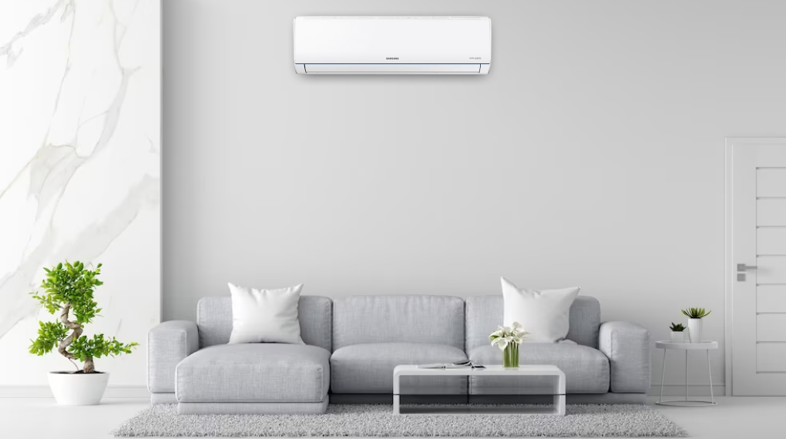](https://cdn.tgdd.vn/Products/Images/2002/309828/samsung-inverter-1-hp-ar12tyhqasinsv-030723-050333.jpg)

*\* Images are for illustration purposes only*

**Outdoor**

The rectangular box-shaped condenser has a sturdy design with **copper gas pipes** that help the gas pumping process quickly and ensure cooling capacity. **The aluminum heatsink** is compact and lightweight, convenient for product installation while ensuring the machine always operates stably.

**Refrigeration technology**

- It is [a 1.5 HP air conditioner](https://www.dienmayxanh.com/may-lanh?g=15-hp) so it is suitable for room space from **15 - 20m² (from 40 to 60 m³)** .

- **Fast Cool & Comfort Cool mode** will quickly help the room reach the set temperature through the fastest cooling efficiency mechanism, to bring a comfortable and pleasant room space.

**Air blowing mechanism**

[This Samsung air conditioner](https://www.dienmayxanh.com/may-lanh-samsung) operates with a custom up and down control mechanism so that the wind direction is spread evenly throughout the space, bringing a comfortable feeling when used.

**Power saving technology**

Equipped with **Digital Inverter Boost technology** with integrated permanent magnets and silencer to help the machine operate stably, maintain a smooth operating temperature and save energy during use.

**Air filtering ability**

The HD filter can filter out coarse dust particles, allergens, pollen, mold, and pet hair, thereby providing a fresh space. A special feature is that the filter can be easily cleaned with water.

**Utilities**

- **Good Sleep mode** automatically adjusts the temperature, thereby creating a more pleasant and comfortable nighttime environment.

- **On-off timer** allows you to proactively set the operating and shutdown times of [the air conditioner](https://www.dienmayxanh.com/may-lanh) , both saving electricity and helping you not waste time finding the remote to turn on/off the air conditioner, especially at night.

- When an incident occurs, the air conditioner can automatically **restart automatically when electricity is available** .

[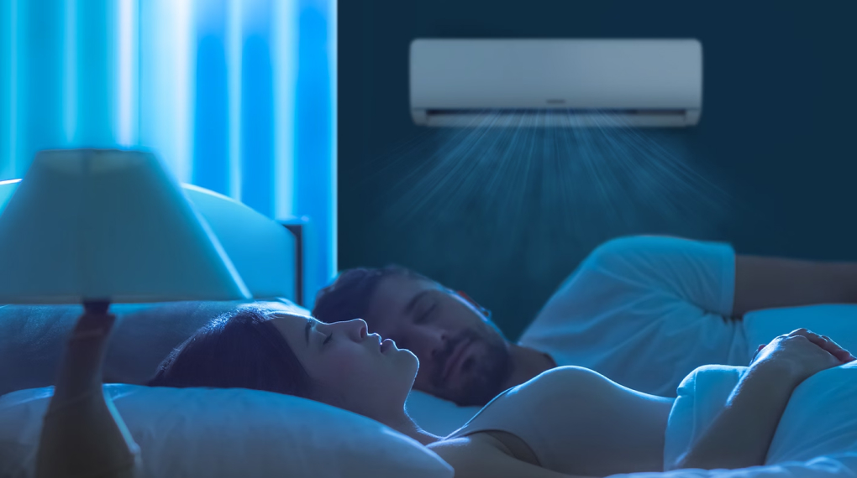](https://cdn.tgdd.vn/Products/Images/2002/309828/samsung-inverter-1-hp-ar12tyhqasinsv-030723-050355.jpg)

*\* Images are for illustration purposes only*

*In short, this is a product that will meet the needs of space cooling with a variety of features such as quick cooling, night sleep mode, dust filtering ability,... ensuring a cool and fresh space.*